**Demonstrate how to create the first API request**

Step-1:

First open postman

Step-2:

Then click on new button

Step-3:

Then click on HTTP

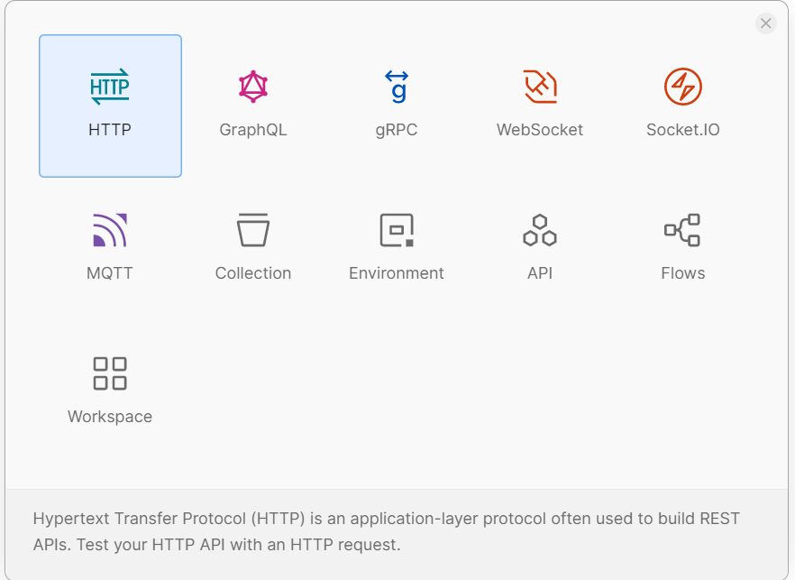

Step-4:

Then I enter get request url

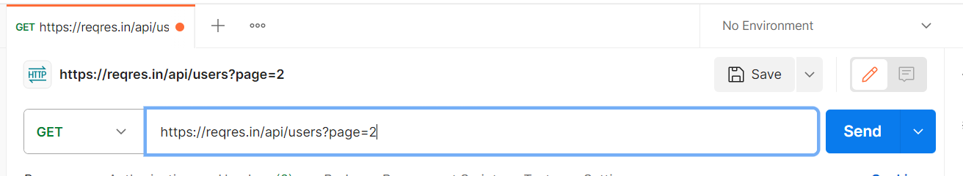

Step-5:

Then I click on send button

